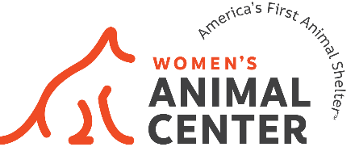
Board Member Opportunity
Women’s Animal Center, Bensalem, PA

Women’s Animal Center, America’s First Animal Shelter is currently seeking nominations for its Board of Directors. Located in Bensalem, Bucks County, we seek women who are passionate about animal welfare and have business management experience to provide oversight and stewardship of the organization.

Mission:
With compassion and caring as our foundation, Women’s Animal Center saves the lives of animals and improves the health of pets through sheltering and adoptions, veterinary services, community partnerships, educational resources and advocacy. Founded in 1869 as America’s First Animal Shelter™, we honor the legacy of our founders by ensuring that animals are treated humanely and with kindness.
Board of Director position: Women’s Animal Center seeks to fill 2 open Board of Directors positions.

Our Board is currently comprised of all women, per our Bylaws and to honor the legacy of our organization which was founded by women 154 years ago in 1869.

EXPECTATIONS:
Leadership, governance and oversight:
- Develop, approve and adhere to organizational Bylaws and policies
- Approve strategic plan and direction
- Oversee the selection and compensation of the CEO
- Provide oversight and stewardship of the organization’s finances
- Approve the annual operating budget recommended by management
- Verify that the use of assets is consistent with the mission of the organization, regulatory requirements and accepted accounting principles; and take steps to minimize the possibility of fraud

Fundraising:
- Support, advocate, and promote the organization to advance the mission
- Attend fundraising events and share event details with colleagues and friends
- Introduce friends and colleagues to Women’s Animal Center and invite them to tour The Center.
- Make a personally meaningful contribution to the annual fund.

Board Members are elected to two year terms. Board meetings are held 6 times per year – with a combination of viral and online meetings. Committee assignments are made after joining the board and are in addition to regular Board Member duties.

QUALIFICATIONS DESIRED:
Founded by a group of women in 1869, Women’s Animal Center’s Board of Directors is comprised of all women, per our Bylaws.

We currently seek women with expertise and experience in business management and/or financial management

Start Date: June 2023

TO APPLY: Please direct all inquiries regarding the Women’s Animal Center board of directors to:
Catherine Malkemes, Chief Executive Officer, cmalkemes@womensanimalcenter.org

